Personal Budget Tracker
A Native macOS Budgeting App
Full Project Specification & Design Document
Prepared for personal use — internship income budgeting
Version 1.1 • August 2026

Table of Contents
1. Project Overview
1.1 Goals
1.2 Non-Goals
2. Feature Scope
2.1 Phase 1 — MVP
2.2 Phase 2 — Extensions
3. Technology Stack
4. System Architecture
5. Database Schema
5.1 categories
5.2 transactions
5.3 savings
5.4 settings
5.5 emergency_fund
5.6 recurring_transactions
5.7 emergency_fund_log
6. Core Business Logic
6.1 Soft Limit vs Hard Limit
6.2 Savings Rollover
6.3 Emergency Fund
6.4 Recurring Transaction Approval
7. UI / UX Design
7.1 Dashboard (Home)
7.2 Add Transaction
7.3 Transaction List
7.4 Settings
7.5 Chatbot Popup (Phase 2)
7.6 Pending Approvals (Phase 2)
8. Automation & Scheduled Logic
9. Packaging & Distribution (macOS)
10. Roadmap
11. Appendix — Full Schema (SQL)

1. Project Overview
This document is the complete design specification for a personal budgeting application, built from scratch to track income and spending during a paid internship. The goal is a low-friction, private, single-user tool that runs as a native application on macOS — not a spreadsheet, not a cloud service, and not dependent on a subscription.
The app is being built in phases. Phase 1 (MVP) delivers core transaction tracking, category budgets with soft/hard limits, savings rollover, emergency fund allocation, and dashboard visuals. Phase 2 layers in a free AI chatbot assistant and recurring-transaction automation.

1.1 Goals
- Track income and expenses with minimal friction — adding a transaction should take seconds.
- Organize spending into categories (Food, Books, Transport, etc.) with per-category budgets.
- Distinguish between a soft limit (personal aspiration) and a hard limit (the real monthly budget ceiling).
- Automatically roll unspent budget into savings at month end — no manual calculation.
- Keep an emergency fund separate and only touched intentionally, funded by an automatic monthly transfer plus optional manual top-ups, with a transparent log.
- Visualize spending trends and category health at a glance, including where the month is projected to land.
- Eventually, ask a chatbot natural-language questions about the budget ("how much do I have left for food?").
- Ship as a real double-clickable macOS app, not a script that needs a terminal.

1.2 Non-Goals
- Multi-user support — this is a single-user, local-only application.
- Bank account syncing / Plaid integration — all entries are manual, logged after the fact.
- Investment tracking or tax preparation.
- Cloud sync (at least for v1) — the SQLite file lives locally; backup is the user's responsibility.

2. Feature Scope

2.1 Phase 1 — MVP
- Add Transaction — amount, category, description, date (defaults to today), optional funding-source tag.
- Transaction List — sortable, filterable table view (by category, date range, type, and pending-approval status).
- Dashboard — this month's spending by category, soft/hard limits shown as tick marks on a scale beneath each bar, pie chart, a category-switchable monthly trend line, and a current-month pace chart with a projected month-end line.
- Category Management — create/edit/delete categories with dynamic soft and hard limits (no hardcoded defaults baked into code).
- Savings Tracking — automatic month-end rollover of unspent budget into a running savings total, after the emergency fund's monthly allocation is set aside.
- Emergency Fund — separate balance, funded automatically each month (up to a configurable cap) plus optional manual top-ups at any time; spending from it is still tagged via the funding-source tag, with a visible history of every deposit and withdrawal.
- Settings Page — edit default soft/hard limits, warning thresholds, emergency fund automation, and other configurable values.

2.2 Phase 2 — Extensions
- LLM Chatbot Popup — small floating window powered by Google's Gemini API (a free tier that needs no billing setup), with read access to the budget database to answer questions.
- Recurring Transactions — daily, monthly, yearly, or custom-interval (every N days) rules for fixed items (rent, subscriptions). Each occurrence is created as a Pending Approval transaction that the user reviews — and can adjust the amount or date for — before it counts toward any total, so a rent payment that lands on the 4th instead of the 1st is never mis-recorded.
- Reports & Export — CSV/PDF export of monthly summaries.
- Notifications — optional local alerts when a category crosses its hard limit.

3. Technology Stack
Category | Choice | Rationale
Language | Python 3.12 | Single language across app logic, UI, and packaging.
Storage | SQLite (sqlite3, built-in) | Single-file local database. No server process, easy to back up by copying one file.
UI Framework | CustomTkinter | Modern-looking, native-feeling widgets with far less boilerplate than raw Tkinter or PyQt.
Charts | Matplotlib | Embedded directly into CustomTkinter frames via FigureCanvasTkAgg.
Packaging | PyInstaller | Bundles the app + interpreter + dependencies into BudgetApp.app for macOS.
Chatbot (Phase 2) | Gemini API (Google, free tier) | Read-only access to the local database through the app layer; uses Google's no-cost free tier so it never requires a paid plan; no data leaves the machine except the chat query itself.
Why not MySQL? A local personal-finance app has exactly one user and no concurrent-access requirements — running a database server for that is unnecessary overhead. SQLite gives the same SQL query power in a single portable file.
Why not Excel as the primary store? Excel is fine for casual tracking but weak at enforcing relationships (e.g., a transaction referencing a valid category) and at running the kind of conditional logic the soft/hard limit and rollover rules require. SQLite plus a custom UI gives full control over both.
Why Gemini instead of Claude for the chatbot? Google's Gemini API offers a free usage tier that doesn't require adding a credit card, which fits a hobby project's "never pay for this" requirement better than a metered API. If free-tier limits ever become a problem, the app layer's chatbot integration is isolated enough to swap providers without touching the rest of the codebase.

4. System Architecture
The application is a single desktop process with four logical layers: the UI, the application/business-logic layer, the data layer, and (in Phase 2) an external API call to Google's Gemini for the chatbot.
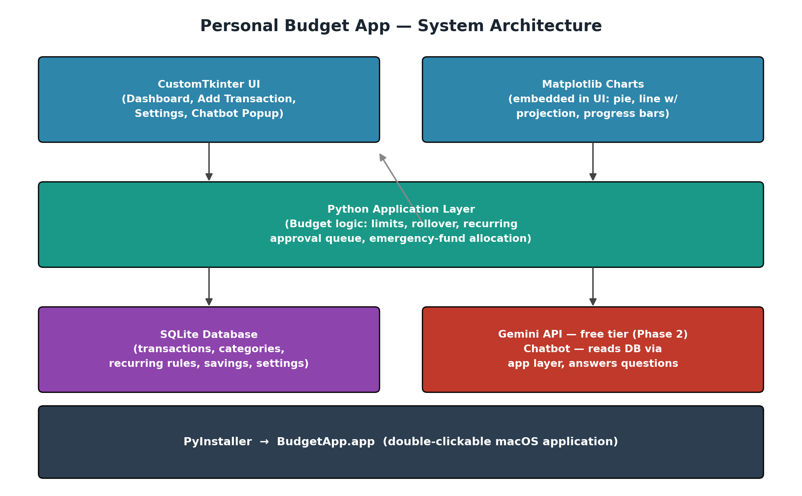
Figure 1 — System architecture overview.
The application layer is the important design decision here: all budget rules (limit checking, rollover math, emergency-fund allocation, recurring-transaction approval) live in plain Python functions that are completely independent of the UI. This means the UI layer only ever calls functions like add_transaction(...) or get_dashboard_summary(...) — it never touches SQL directly. That separation makes the logic testable on its own and makes it possible to swap the UI later without touching business rules.

5. Database Schema
All data lives in a single SQLite file (budget.db). Seven tables cover the whole app.
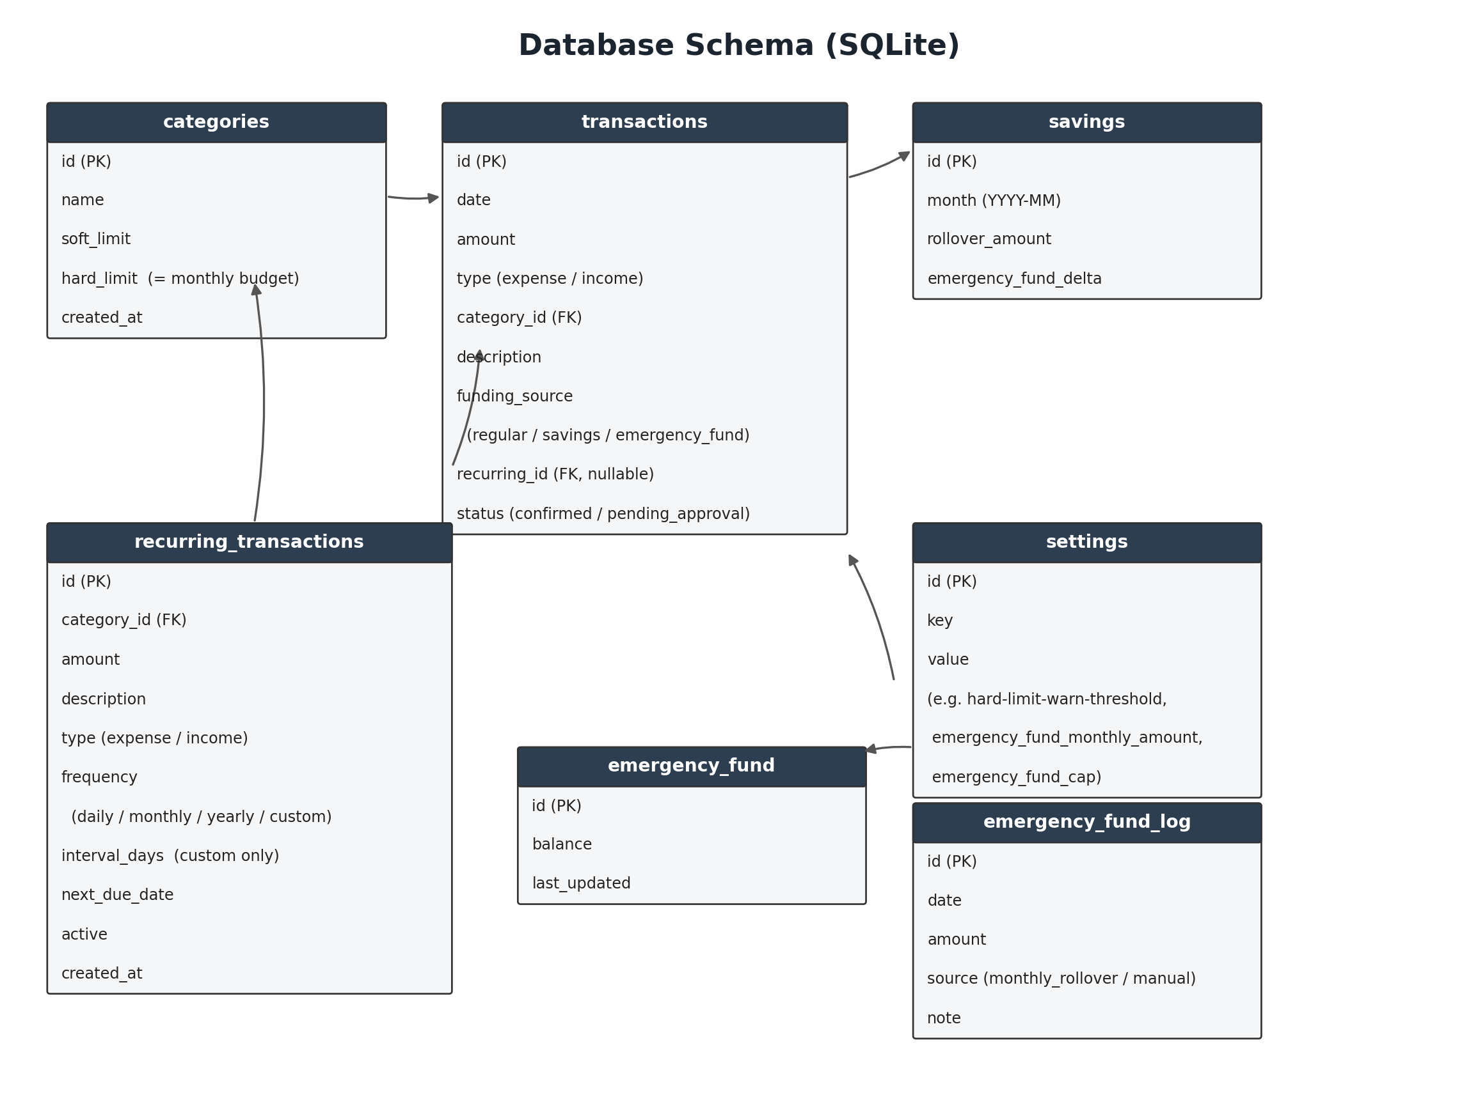
Figure 2 — Entity-relationship diagram.

5.1 categories
Field | Type | Notes
id | INTEGER PK | Auto-increment.
name | TEXT | e.g. "Food", "Books". Unique.
soft_limit | REAL | Aspirational monthly ceiling. Editable in Settings.
hard_limit | REAL | Real monthly budget for the category. Spending beyond this overflows into savings.
created_at | TEXT | ISO timestamp.

5.2 transactions
Field | Type | Notes
id | INTEGER PK | Auto-increment.
date | TEXT | ISO date; defaults to today, editable for back-logging.
amount | REAL | Positive number.
type | TEXT | "expense" or "income".
category_id | INTEGER FK | References categories.id. Null for income.
description | TEXT | Free-text note entered when logging.
funding_source | TEXT | "regular" (default) / "savings" / "emergency_fund" — self-reported.
recurring_id | INTEGER FK, nullable | References recurring_transactions.id when this row was generated by a recurring rule; null for manually entered transactions.
status | TEXT | "confirmed" (default) or "pending_approval". Pending rows are excluded from all totals, limits, and charts until approved (Section 6.4).

5.3 savings
Field | Type | Notes
id | INTEGER PK | Auto-increment.
month | TEXT | "YYYY-MM".
rollover_amount | REAL | Computed at month close: sum of per-category leftovers, minus whatever was diverted to the emergency fund that month.
emergency_fund_delta | REAL | Net change to emergency fund that month, from the automatic monthly transfer plus any manual top-ups or emergency withdrawals.

5.4 settings
Field | Type | Notes
id | INTEGER PK | Auto-increment.
key | TEXT | e.g. "hard_limit_warn_threshold", "emergency_fund_monthly_amount", "emergency_fund_cap".
value | TEXT | Stored as text, cast on read. Keeps all thresholds — including the emergency fund's monthly transfer amount and cap — dynamic and user-editable.

5.5 emergency_fund
Field | Type | Notes
id | INTEGER PK | Single row, effectively a singleton.
balance | REAL | Running balance.
last_updated | TEXT | ISO timestamp of last change.

5.6 recurring_transactions
Field | Type | Notes
id | INTEGER PK | Auto-increment.
category_id | INTEGER FK | References categories.id.
amount | REAL | Expected amount; editable per-occurrence when approving (Section 6.4).
description | TEXT | e.g. "Rent", "Netflix".
type | TEXT | "expense" or "income".
frequency | TEXT | "daily" / "monthly" / "yearly" / "custom".
interval_days | INTEGER, nullable | Only used when frequency = "custom" — repeat every N days.
next_due_date | TEXT | ISO date the rule will next generate a pending transaction.
active | INTEGER (boolean) | Paused rules stop generating new pending transactions without being deleted.
created_at | TEXT | ISO timestamp.

5.7 emergency_fund_log
Field | Type | Notes
id | INTEGER PK | Auto-increment.
date | TEXT | ISO date of the deposit.
amount | REAL | Positive amount added to the fund.
source | TEXT | "monthly_rollover" (automatic) or "manual" (user-initiated top-up).
note | TEXT | Optional free-text note.

6. Core Business Logic

6.1 Soft Limit vs Hard Limit
These two numbers are set per category and are fully dynamic — nothing about them is hardcoded, and both can be edited any time from Settings, though the app also supports sensible defaults for new categories.
- Soft limit — a personal, casual target. "I'd like to stay under this." Crossing it changes the category's dashboard color to a warning shade but has no other effect.
- Hard limit — the category's actual monthly budget. This is the meaningful ceiling: spending beyond it is spending that comes out of savings, not out of "budgeted" money.
Because transactions are logged after they happen, no limit ever blocks an entry — the app cannot stop money that has already been spent. Instead, limits are purely informational signals shown at the right moments: on the dashboard, and when adding a transaction in a category that is close to or past its hard limit. Pending-approval transactions generated by a recurring rule (Section 6.4) are excluded from these running totals until the user confirms them.
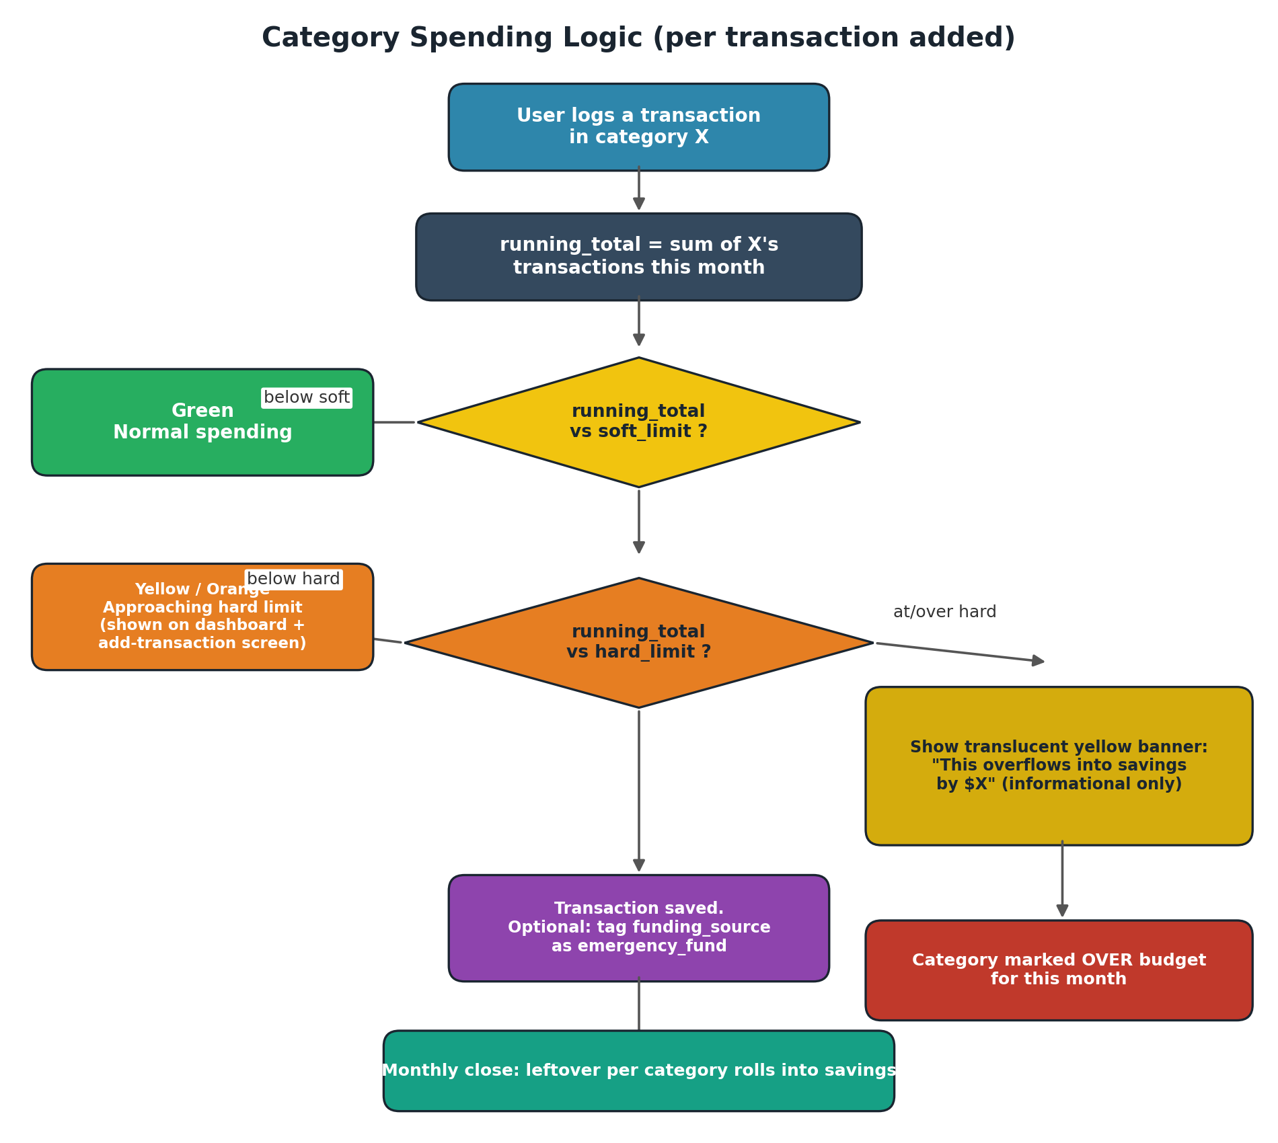
Figure 3 — Per-transaction spending logic.

Approaching the hard limit
When adding a transaction, if the category's running total is within a configurable threshold of its hard limit (a Settings value, e.g. within $50 or 20%), the add-transaction screen shows a message such as "You're $50 away from your Food hard limit." The same proximity indicator appears on the dashboard as a shifting progress-bar color.

Crossing the hard limit
If the new transaction would push (or has pushed) the category over its hard limit, the add-transaction window shows a translucent yellow banner naming the category and the overflow amount — for example, "This overflows into savings by $15." This is purely informational: it explains where that money is conceptually coming from, since it can no longer be considered part of the month's category budget. The category is then marked over budget for the rest of the month on the dashboard.

6.2 Savings Rollover
At the close of each month, for every category the app computes:
leftover = max(hard_limit − actual_spent, 0)
Overspent categories contribute zero — never negative — to the rollover total, but the overspend still reduces the amount available to save, because it was real money spent. Summing leftover across all categories (equivalently: income minus total spending) gives the month's total leftover.
Before that leftover becomes savings, the app applies the emergency fund rule from Section 6.3: up to the configured monthly amount is diverted into the emergency fund first (unless its cap has already been reached), and only what remains is added to the running savings balance. No manual step is required for either transfer, though the amounts and cap can be changed any time in Settings.

6.3 Emergency Fund
The emergency fund is deliberately kept separate from the soft/hard limit system, and it now funds itself — no manual monthly calculation is needed, though the person can still add to it whenever they like.
- Monthly auto-transfer — at month close, before the remaining leftover rolls into savings (Section 6.2), the app moves min(emergency_fund_monthly_amount, emergency_fund_cap − balance) into the emergency fund. This is Settings-configurable and defaults to $0 (off) until set.
- Cap — once emergency_fund.balance reaches emergency_fund_cap, the automatic transfer stops entirely and the full monthly leftover rolls into savings instead, so the fund never grows past the size the person considers "enough."
- Manual top-up — at any time, from the Emergency Fund view (Section 7.4), the person can add a specific amount directly to the fund, outside of the month-end cycle.
- Every automatic transfer and manual top-up is written to emergency_fund_log, so the full deposit history is auditable alongside the running balance.
- Spending from the fund is unchanged from before: the user can tag a transaction as sourced from "emergency_fund" at logging time — this is a self-report, purely for the user's own record-keeping, since transactions are entered after the money is already spent.
- When a category crosses its hard limit, the app shows the overflow-into-savings banner as informational context; it does not ask a yes/no question, since the spending already happened and there is no decision left to make in the moment.
- A dedicated view (Section 7.4) shows the full history of emergency-fund-tagged spending, the deposit log, and the running balance over time.

6.4 Recurring Transaction Approval
Recurring rules never write a confirmed transaction directly. Real spending — rent, a subscription, anything on a schedule — rarely lands on the exact same date or exact same amount every cycle, so silently auto-logging it would produce numbers the person didn't actually see happen.
- When a rule's next_due_date arrives, the app inserts a new row into transactions with status = "pending_approval" and the rule's default amount, category, and description.
- That row is surfaced in a Pending Approvals list (Section 7.6) rather than the regular transaction list, and it is excluded from category totals, hard-limit checks, and dashboard charts until it is resolved.
- From the Pending Approvals list, the person can edit the amount and date to match what actually happened — for example, changing a rent entry from the 1st to the 4th — then Approve it, which flips status to "confirmed" and folds it into the month's numbers.
- Alternatively the person can Skip a given occurrence (e.g. a subscription that was cancelled that month); the pending row is discarded and the rule's next_due_date advances as normal.
- Frequencies supported: daily, monthly, yearly, and a custom interval of every N days, covering everything from a daily coffee budget line to an annual insurance premium.

7. UI / UX Design
Five primary screens, plus the Phase 2 chatbot popup.

7.1 Dashboard (Home)
- This month's total spending vs. total income.
- Per-category spending bars: green under soft limit, orange approaching hard limit, red/purple at or over hard limit. Soft and hard limits are drawn as tick marks standing on a horizontal scale line beneath each bar — rather than a shaded background box — so both limits stay visible even when a bar overflows past them.
- Pie chart of spending by category. Clicking a category slice switches the trend line chart below to that category's own history; pressing Esc (or clicking the slice again) returns to the all-categories view.
- A monthly trend line chart (spending and savings-rollover) over the last 6 months, defaulting to "All Categories" and filterable by clicking the pie chart as above.
- A current-month pace chart: cumulative spending so far this month as a solid line, continuing as a dashed projection — based on the current daily average — out to a predicted month-end total.
- Current savings balance and emergency fund balance, shown prominently, with a quick "Add to Emergency Fund" action for manual top-ups.
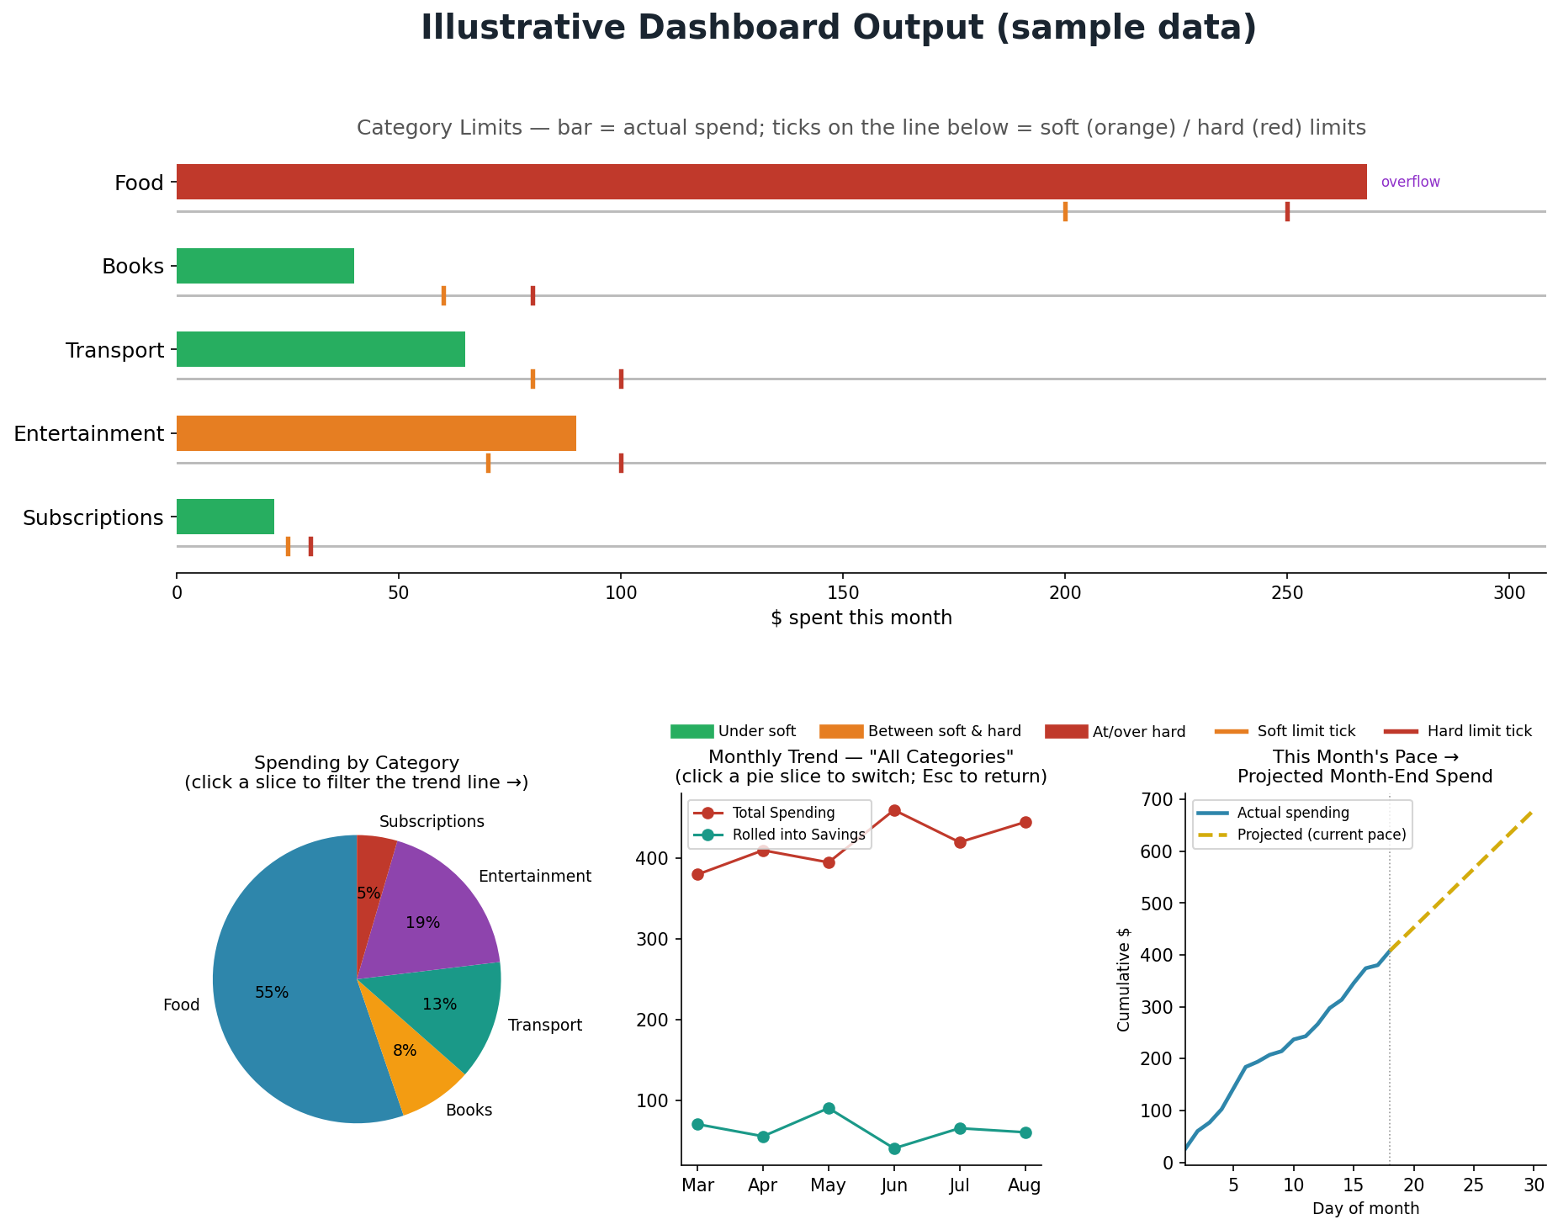
Figure 4 — Illustrative dashboard output using sample data.

7.2 Add Transaction
- Fields: amount, category (dropdown), description (free text), date (defaults to today, editable for back-logging), type (expense/income).
- Optional funding-source selector, only relevant once a category is near/over its hard limit.
- Live inline feedback: proximity-to-hard-limit message, and the translucent yellow overflow banner when applicable.
- Transactions generated from a recurring rule instead open pre-filled from the Pending Approvals list (Section 7.6), with the same fields editable before they're approved.

7.3 Transaction List
- Sortable table: date, category, description, amount, funding source.
- Filters: category, date range, type, and a toggle to show only items awaiting approval.
- Edit / delete existing entries (recalculates all downstream totals).

7.4 Settings
- Manage categories: add/edit/delete, set soft_limit and hard_limit per category.
- Global thresholds: hard-limit warning distance, default currency, etc.
- Emergency fund automation: set the monthly transfer amount and the cap at which it stops, plus manual balance adjustment (for initial setup) and a manual top-up control.
- Recurring rules: add, edit, or pause daily / monthly / yearly / custom-interval rules per category.
- Emergency fund history: the full deposit log (automatic and manual) and emergency-fund-tagged spending, alongside the running balance.

7.5 Chatbot Popup (Phase 2)
A small always-on-top floating window, toggled from the main app. It sends the user's question plus a relevant read-only snapshot of budget data (current month's totals, category limits, savings/emergency balances) to Google's Gemini API — using its free tier, so it costs nothing to run — and returns a natural-language answer, e.g. "How much can I still spend on food this month?" or "Did I save more in June or July?"

7.6 Pending Approvals (Phase 2)
A dedicated list, reachable from the main navigation and badged with a count when items are waiting, showing every recurring-generated transaction that hasn't been approved yet.
- Each row shows the rule's description, category, expected amount, and due date, with the amount and date editable inline.
- Approve confirms the row as a real transaction with today's (or the edited) values; Skip discards just that occurrence without affecting the underlying rule.
- See Figure 5 (Section 8) for the full approval flow, and Section 6.4 for the underlying logic.

8. Automation & Scheduled Logic
- Month-end rollover job — runs automatically on first app launch of a new month: computes each category's leftover, diverts the emergency fund's monthly amount (if not already at its cap), and writes the remainder as that month's savings contribution.
- Hard-limit proximity checks — evaluated live on every transaction add, not on a schedule.
- (Phase 2) Recurring transactions — daily, monthly, yearly, or custom-interval rules generate a pending_approval transaction on each due date; nothing is finalized until the user approves it, so logging rent on the day it actually left your account — not the 1st by default — is the expected flow, not a workaround.
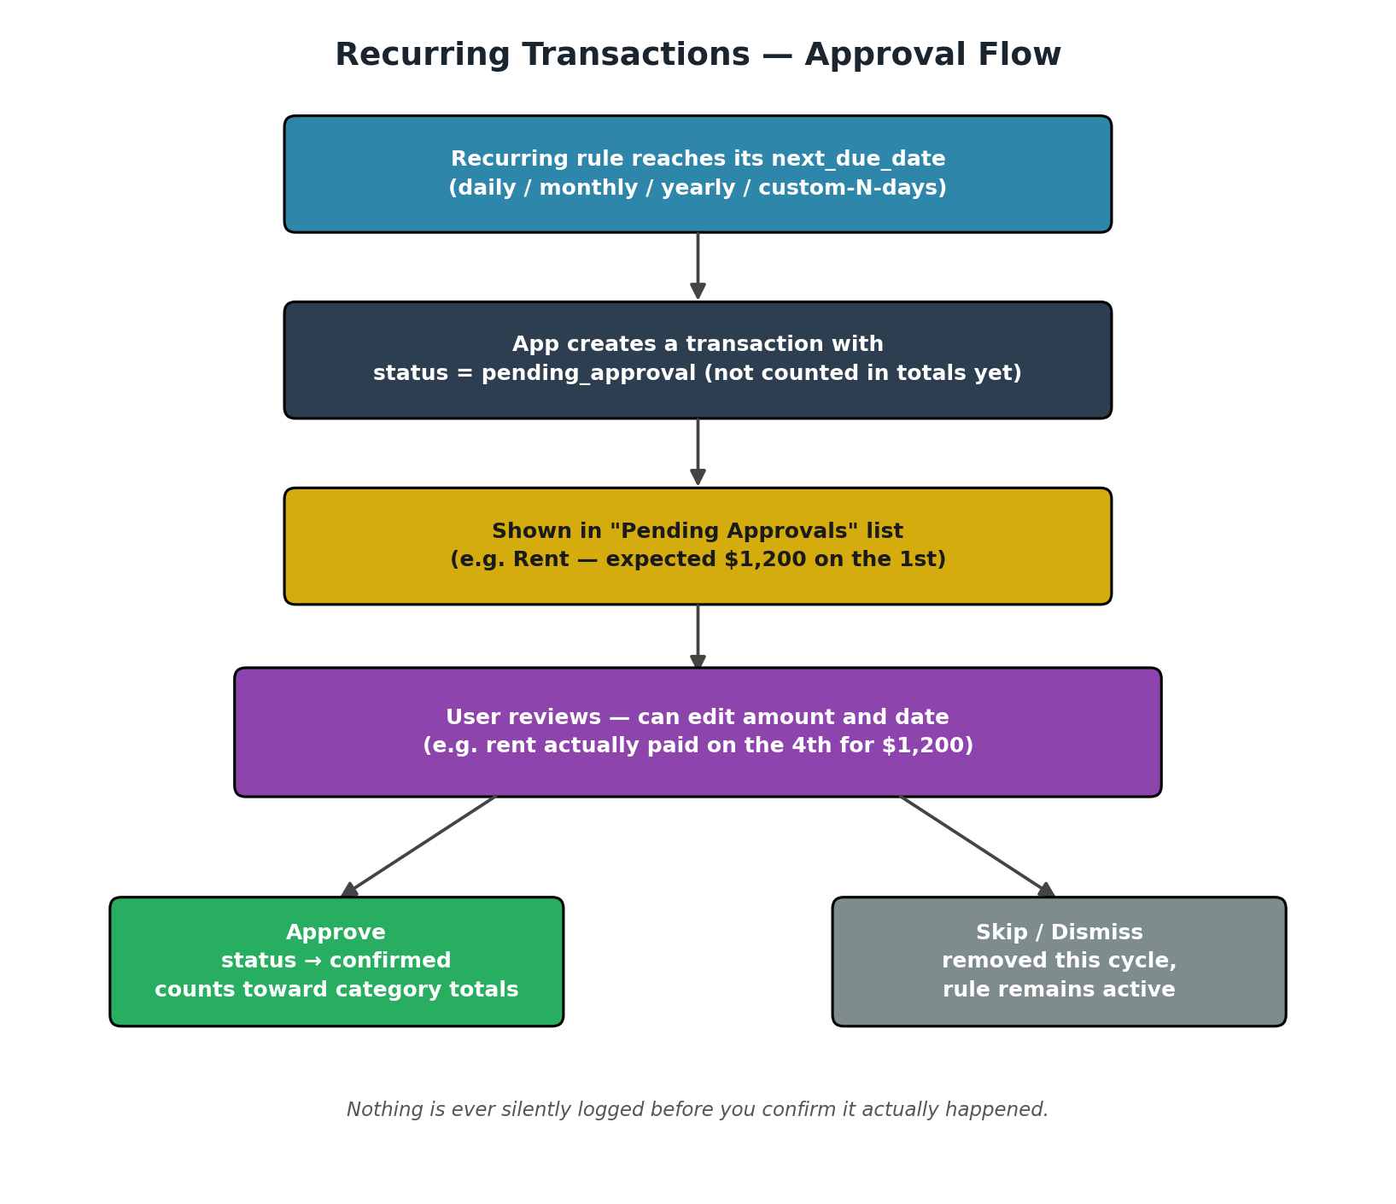
Figure 5 — Recurring transactions approval flow.

9. Packaging & Distribution (macOS)
PyInstaller bundles the Python interpreter, CustomTkinter, Matplotlib, and the SQLite file's schema (not the user's data) into a self-contained .app bundle.
- Develop and test the app normally with python main.py.
- Run pyinstaller --windowed --name "BudgetApp" --onedir main.py to produce dist/BudgetApp.app.
- Verify the .app launches standalone (no system Python required) on a clean user account.
- Optionally code-sign with a local Apple Developer certificate to avoid Gatekeeper warnings; without one, the user right-clicks → Open the first time.
- Move BudgetApp.app to /Applications. The SQLite database file is created on first run in the user's Application Support folder, so it persists across app updates.

10. Roadmap
Milestone | Deliverable | Phase
Milestone 1 | SQLite schema + core Python data-access functions | Foundation
Milestone 2 | CustomTkinter shell: navigation, Add Transaction, Transaction List | MVP UI
Milestone 3 | Dashboard with embedded Matplotlib charts (limit lines, category-switchable trend, month-end projection) + limit logic | MVP complete
Milestone 4 | Settings page, savings rollover job, emergency fund automation + view | MVP complete
Milestone 5 | PyInstaller packaging into BudgetApp.app | v1.0 ship
Milestone 6 | Gemini API chatbot popup (free tier) | Phase 2
Milestone 7 | Recurring transactions with Pending Approvals queue, export, notifications | Phase 2

11. Appendix — Full Schema (SQL)
CREATE TABLE categories (
id INTEGER PRIMARY KEY AUTOINCREMENT,
name TEXT UNIQUE NOT NULL,
soft_limit REAL NOT NULL,
hard_limit REAL NOT NULL,
created_at TEXT NOT NULL
);

CREATE TABLE transactions (
id INTEGER PRIMARY KEY AUTOINCREMENT,
date TEXT NOT NULL,
amount REAL NOT NULL,
type TEXT NOT NULL CHECK(type IN ('expense','income')),
category_id INTEGER REFERENCES categories(id),
description TEXT,
funding_source TEXT NOT NULL DEFAULT 'regular'
CHECK(funding_source IN ('regular','savings','emergency_fund')),
recurring_id INTEGER REFERENCES recurring_transactions(id),
status TEXT NOT NULL DEFAULT 'confirmed'
CHECK(status IN ('confirmed','pending_approval'))
);

CREATE TABLE savings (
id INTEGER PRIMARY KEY AUTOINCREMENT,
month TEXT UNIQUE NOT NULL,
rollover_amount REAL NOT NULL,
emergency_fund_delta REAL NOT NULL DEFAULT 0
);

CREATE TABLE settings (
id INTEGER PRIMARY KEY AUTOINCREMENT,
key TEXT UNIQUE NOT NULL,
value TEXT NOT NULL
);

CREATE TABLE emergency_fund (
id INTEGER PRIMARY KEY AUTOINCREMENT,
balance REAL NOT NULL DEFAULT 0,
last_updated TEXT NOT NULL
);

CREATE TABLE recurring_transactions (
id INTEGER PRIMARY KEY AUTOINCREMENT,
category_id INTEGER REFERENCES categories(id),
amount REAL NOT NULL,
description TEXT,
type TEXT NOT NULL CHECK(type IN ('expense','income')),
frequency TEXT NOT NULL CHECK(frequency IN ('daily','monthly','yearly','custom')),
interval_days INTEGER,
next_due_date TEXT NOT NULL,
active INTEGER NOT NULL DEFAULT 1,
created_at TEXT NOT NULL
);

CREATE TABLE emergency_fund_log (
id INTEGER PRIMARY KEY AUTOINCREMENT,
date TEXT NOT NULL,
amount REAL NOT NULL,
source TEXT NOT NULL CHECK(source IN ('monthly_rollover','manual')),
note TEXT
);

